Synoptic Control of Cross-Barrier Precipitation Ratios for the Cascade Mountains

Clifford Mass, Neal Johnson, and Michael Warner
University of Washington
Seattle, Washington

Ricardito Vargas
City University of New York

Submitted to the Journal of Hydrometeorology
July 2014

Abstract
This paper examines the synoptic control of precipitation contrasts across the Cascade Mountains of Washington State during the cool season. The average hourly precipitation for three stations on the western and eastern sides of the barrier is calculated, and composite synoptic conditions are determined for situations when precipitation is greater over the eastern slopes, similar precipitation falls on both sides, moderately greater precipitation falls on the western side, and when substantially greater precipitation falls on the western side. Conditions prior to occluded/warm frontal passage are favorable for relatively equal precipitation amounts on both sides of the barrier, with extensive warm advection precipitation spreading over the region. Low-level winds are more southerly during this period, resulting in less orographic modulation of precipitation on the north-south oriented Cascades. In contrast, post-frontal conditions are associated with stronger westerly flow, enhanced windward precipitation, and greater drying on the leeward (eastern) slopes. Post-frontal conditions are also associated with drying aloft and reduced stability at low levels, both of which contribute to the enhancement of precipitation on the western slopes.
The variation of the cross-mountain precipitation ratio between El Niño and La Niña years can be explained by the associated synoptic configurations. El Niño years have weaker zonal winds and thus less orographic modulation. Furthermore, the lesser vertical stability of La Niña years enhances precipitation on the windward side of the barrier where shallow convection is released.

1. Introduction
The substantial precipitation contrasts across mountain barriers, with windward enhancement on one side and leeward reduction on the other, have been the subject of many observational and theoretical studies (e.g., Sinclair et al. 1997, Colle et al. 2004, Dettinger et al. 2004). A lesser number of papers have examined the temporal variability of orographic precipitation contrasts, or the control of such variability by the synoptic-scale flow. For example, Siler et al. (2013) found that the intensity of the winter-mean rain shadow across the Washington Cascades was weaker in El Niño than La Niña years, and suggested that the strongest (weakest) rain shadows occurred for warm-sector (warm-frontal) situations. Dettinger et al. (2004) examined the synoptic controls of windward orographic precipitation ratios for the Sierra Nevada of California, with ratios defined by the difference in precipitation between the low-elevation Central Valley and the western slopes of the barrier. They found increased ratios when the flow was more normal to the terrain and vertical stability was reduced, as well as higher ratios after cold frontal passage compared to the warm sectors of midlatitude cyclones. Steenburgh (2004), examining precipitation across Utah’s Wasatch Range, found less orographic enhancement during frontal passage than during post-frontal convective showers.
Other studies have examined the relationship between the orographic precipitation distribution and the characteristics of the approaching flow. Sinclair et al. (1997), examining precipitation spillover across the Southern Alps of New Zealand, found that leeside precipitation was enhanced with increasing wind speed and decreasing vertical stability. Chater and Sturman (1998) found that precipitation falling to the lee of the New Zealand Alps is highly correlated with incoming wind speed and the strength of associated frontal systems. Hayes et al. (2001) and Rasmussen (2001) showed that precipitation variations across the Cascade and Olympic Mountains are related to the 850-hPa moisture flux across the barriers determined from coastal soundings at Quillayute, Washington. Neiman et al. (2002) found that orographic precipitation on California’s coastal mountains is highly correlated with the upslope component near crest level. The sensitivity of orographic precipitation to variations in wind speed normal to the barrier, stability, freezing level and terrain geometry was examined in a modeling framework by Colle (2004). Underwood et al. (2009) found greater precipitation spillover to the lee of the Sierra Mountains for storms with deeper moisture, warmer conditions, and stronger westerly winds in the lower to mid-troposphere.
Several studies have examined the microphysical evolution above the Cascade Mountains as wintertime fronts and cyclones pass eastward across the area. For example, Farber (1971) and Hobbs (1975) described three major stages of such winter storms. First, during pre-frontal conditions ice particles dominate, clouds are layered with tops reaching 7.5 to 10.5 km, and the atmosphere is stable, moist, and warm. Ice crystals can be advected far downstream to the lee of the barrier in the westerly flow aloft. Next, the transitional stage is characterized by frontal passage aloft, the beginning of mid-tropospheric cold-air advection, and decreasing atmospheric stability. Winds become more westerly and orographic enhancement becomes more pronounced. Finally, in the post-frontal stage the atmosphere becomes more convective and unstable, with cloud tops lowering as drier air floods in above approximately 600 hPa. Orographic enhancement of precipitation and clouds along the western (windward) slopes is pronounced during this stage, with substantial drying over the eastern slopes of the Cascades.
Medina et al. (2007) used radar observations to describe the vertical precipitation structure as midlatitude cyclones crossed the Oregon Cascades during the 2001 IMPROVE-2 field program. Similar to Farber (1971) and Hobbs (1974), they found that precipitation evolution could be separated into three major phases. In the early sector, precipitation is associated with deep warm advection that appears aloft first and then descends to the surface. Orographic effects are relatively minor during this stage. During the middle sector of the storm, there is a transition from warm to cold advection and precipitation over the windward slopes become more intense, with a double radar echo maximum over and upwind of the crest. In the late sector of cyclone passage, cold advection dominates and precipitation is generally in the form of isolated, shallow convective elements that are predominantly upstream of and over the windward slopes, with very little precipitation in the lee.
The temporal variability of precipitation across the north-south oriented Cascade barrier during the passage of a synoptic system is illustrated by high-resolution model simulations for 15-17 April 2012, when a moderate-intensity Pacific warm occlusion crossed the region. At 1500 UTC 16 April, the occlusion’s surface trough was approaching the coast, with warm southwesterly flow over the coastal zone and southerly winds above the Cascades at 850 hPa (Figure 1). During this pre-frontal period, the Weather Research and Forecasting (WRF) model 3-hr precipitation ending 1500 UTC simulated moderate precipitation extending from the coast into eastern Washington, with the heaviest amounts over the windward slopes of the Cascades and coastal mountains. Nine hours later (0000 UTC 17 April), the surface trough had crossed the Cascades, the 850-hPa winds had veered into westerlies, and cooler air had moved in aloft (Figure 2). The predicted three-hour precipitation ending this time was nearly entirely limited to the region west of the Cascade crest, with prominent rain shadows to the lee of the Cascades and the Olympic Mountains.
This paper examines how the windward/leeward ratio of precipitation across the Cascade barrier is modulated by midlatitude synoptic evolution, making use of hourly data on both sides of the terrain for a multi-year winter period. Synoptic composites are constructed for periods in which precipitation is much heavier and moderately heavier on the western side, heavier on the eastern side, or nearly equal across the barrier. Several case studies of these precipitation regimes are presented, and the physical connections between synoptic conditions and the changing cross-barrier precipitation contrasts are examined.
2. A cross-Cascade precipitation index
To characterize the precipitation contrasts across the Washington Cascades, two lines of three stations were established on the eastern and western sides of the barrier (Table 1 and Figure 3). On the western slopes of the Cascades there are Spada Lake (451 m ASL), Gold Bar Elementary School (116 m), and the South Fork Tolt Reservoir (538 m). The second line includes Yakima (333 m), Ellensburg (536 m) and Wenatchee (379 m) at the base of the eastern slopes of the Cascades. Table 1 shows that the annual precipitation contrasts between these two lines is substantial, averaging 110 in (2.8 m) on the western side and 8 in (0.2 m) for the eastern line.
Hourly average precipitation along each line was calculated for two years from 1 November through 28 February (2011-2012. 2012-2013), and the difference (west minus east) between these hourly averages were calculated each hour. Figure 4, the frequency histogram of the hourly windward-leeward precipitation difference, is highly skewed towards positive values (heavier precipitation on the western side of the Cascades); however, the peak frequency is at relatively small positive hourly precipitation differences (0-0.01 in (0.25 mm) per hour). Large hourly differences (greater than 0.2 in (5.1 mm) per hour) are highly skewed toward greater precipitation on the windward side.
Figure 5 presents the hourly precipitation averages on both sides of the Cascades, as well as their differences, between 1 August 2011 and 1 August 2013. Hourly precipitation was generally much heavier and more frequent on the western side of the barrier, but as shown in the last panel, there were several occasions when precipitation was heavier on the eastern side of the Cascades. The maximum hourly precipitation values generally peak near 0.35 in (8.9 mm) on the western side and 0.10 in (2.5 mm) on the eastern side of the barrier.
3. Synoptic composites
To examine the cool season (November through February) synoptic conditions associated with variations in the cross-cascade precipitation differences, composites were made using NCEP’s North American Regional Reanalysis (NARR) dataset, which uses the Eta Model (32-km grid spacing) coupled with a frozen assimilation system (Mesinger et al., 2006). Only the cool season is used since the majority of the regional precipitation falls and synoptic control is dominant during that period. The composites were constructed for four situations: when the precipitation was substantially wetter on the west side (P_{west}-P_{east}> = 2.5 mm per hour), moderately wetter on the west side (0.25<P_{west}-P_{east}<2.5 mm per hour), roughly equal on both sides (|P_{west}-P_{east}|<0.25 mm per hour), and greater on the eastern side of the Cascades (P_{east}-P_{wesst}>0.25 mm per hour), based on the hourly averages of the two pairs of three stations noted above. The number of hours in the composites was 207 (much wetter west), 1601 (moderately wetter west), 33 (nearly equal), 67 (wetter east).
Geopotential heights and temperature near the general crest level of the regional terrain (850 hPa) is shown in Figure 6. When the eastern slopes are wetter than the western ones, a distinct 850-hPa trough extends from apparent low in the Gulf of Alaska to western Washington, with moderate warm advection spreading over central and eastern Washington; this configuration is consistent with an occluded or warm front passage along the coast (Fig. 6a). In contrast, when precipitation is nearly the same on both sides of the barrier (Fig. 6b), the composite indicates a shift of the frontal trough to the northeast, with a ridge of warm air over the coastal waters and modest warm advection over the Cascades. On the other hand, when precipitation is moderately greater over the western side of the Cascades, the 850-hPa flow is more westerly over the region, with weak warm advection offshore (Fig. 6c). Finally, when the west side is substantially wetter than the east (Fig. 6d), the westerly flow strengthens and cold advection dominates over eastern Pacific; this configuration is consistent with post-cold frontal or post-occlusion conditions, substantial upslope flow on the western slopes of the Cascades, and a reduction of vertical stability as cooler air moves in aloft. Although not show, the sea level pressure composites are very similar to the 850-hPa height composites described above.
Turning to more regional view, lower-troposphere vertical motion (omega) in the NARR composites evolves progressively as the precipitation contrasts across the Cascades vary (Fig. 7). When the eastern line of stations has greater precipitation, there is rising motion (negative values) at 700 hPa across much of the region (Fig. 7a), consistent with the general warm advection shown in the previous composites. This general pattern is maintained when precipitation contrasts are small, with the loss of upward motion on the lee side of the Cascades (Fig. 7b). When the western slopes are moderately wetter, there is 700-hPa descent on the eastern slopes, consistent with stronger westerly flow (Fig. 7c). Finally, as precipitation becomes relatively heavier on the windward slopes, the vertical motion couplet across the mountain strengthens, with enhanced rising motion over the western slopes of the Cascades and stronger sinking motion on the leeward (eastern) slopes (Fig. 7d). A similar vertical motion pattern was found in the composites at 850 hPa (not shown).
The 700-hPa relative humidity is above 80% for the entire region when precipitation is higher along the eastern line, with some enhancement near and upwind of the Cascade crest over Oregon (Figure 8a). For nearly equal precipitation across the barrier (Fig. 8b), there is a modest enhancement over the western slopes of the Cascades and an increasing gradient over the coastal waters. For moderately heavy precipitation over the western side, relative humidity decreases to roughly 80% over the windward slopes of the Cascades (Fig. 8c). Finally, for a large windward enhancement of precipitation, there is a distinct relative humidity maximum (exceeding 90%) on the western slopes of the Cascades, with a rapid decline in humidity to the west (Fig. 8d) that is consistent with the advection of cooler, drier aloft.
4. Case studies
In order to gain familiarity with the synoptic environments associated with varying cross-Cascade precipitation ratios, three snapshots of synoptic/mesoscale conditions for three of the cross-Cascade precipitation regimes are described below.
Wetter on the eastern slopes: February 29, 2012
Only a relatively limited number of hours during the two winter seasons (67) had wetter conditions on the eastern rather than the western slopes of the Cascades. A typical example of this situation occurred on 0600 UTC 29 February 2012 (Figure 9). The infrared satellite imagery at this time indicates a low center west of the Washington coast and a frontal cloud band extending southeastward over the Cascades and eastern Washington. A WRF model 3-h precipitation forecast ending at this time indicates heavier precipitation on the eastern slopes (Fig. 9b). An 850-hPa WRF forecast for 0600 UTC shows the offshore low center; stretching to the south/southeast from the low there are a trough and tongue of warm air associated with an occlusion (Fig. 9c). A close-up view of 850 hPa heights, winds, and temperatures at 0600 UTC indicate southeasterly, upslope flow over the eastern slopes of the Cascades, consistent with heavier precipitation on that side (Fig. 9d). Finally, the sounding at Quillayute, Washington, on the northwest Washington coast, at 0000 UTC 29 February 2012 indicates saturated conditions below approximately 770 hPa, with a shallow layer of southeasterly flow veering into strong south-southwesterlies above this level, suggesting warm advection (Fig. 9e).
Nearly equal precipitation on both sides: 28 February 2013
At 1500 UTC 28 February 2013, the infrared satellite image shows a frontal band over Washington State, followed by moist flow (Fig. 10a). A short-term WRF forecast indicates precipitation over south and central Cascades, with moderate amounts extending over southeast Washington (Fig. 10b). The regional WRF forecast of 850-hPa heights and temperatures shows warm, southwesterly flow from off the Pacific extending to the Cascades, with a frontal trough from western Washington northwestward into the eastern Gulf of Alaska (Fig. 10c). A close-up view of the 850 hPa forecasts shows upslope flow on both sides of the Cascades, with southwesterly flow to the west and weaker southeasterly flow to the east compared to the previous case (Fig. 10d). In general, lower-tropospheric temperatures are considerably warmer than for the wetter east-side example shown in Figure 9. Finally, the sounding at Quillayute, WA at 1200 UTC 28 February 2013 shows a much deeper saturated layer than for wetter east-side case, with a greater westerly (upslope) component (Fig. 10e). A shallow, easterly layer that is sub-saturated is associated with downslope flow off the Olympics.
Much wetter on the western slopes: 22 February 2012 and 16 February 2013
The infrared satellite image at one such time (0000 UTC 22 February) suggests a broad, moist westerly flow on the northern side of a subtropical anticyclone (Fig. 11a). A visible satellite image a few hours earlier shows a distinct rain shadow (cloud shadow) in the lee of the Cascades and minor rain shadows west of the Olympics and the Oregon coastal mountains (Fig. 11b). The WRF 3-h precipitation ending at 0000 UTC 22 February shows moderate precipitation on the western slopes of the Cascades, with profound rain shadows west of the Cascades and Olympics (Fig. 11c). The 850 hPa WRF forecast for 0000 UTC shows a large anticyclone west of California, a trough over the Gulf of Alaska, and strong, warm low-level westerly flow approaching Washington State (Fig. 11d). A close-up 850-hPa chart (Fig. 11e) indicates west/northwesterly flow on the coast, with weak windward ridges upstream of the terrain crests and lee troughs to their east. The strong, moist westerly flow creates an enhanced mountain wave response, reflected in the height couplet and large precipitation contrast across the Cascades. Finally, the radiosonde sounding at Quillayute, Washington shows west-northwesterly flow of 25-55 kt in the lower troposphere and saturated conditions up to 600 hPa (Fig. 11f), an ideal flow for large windward precipitation.
Another synoptic situation, also associated with strong westerly flow, can produce large differences in precipitation across the Cascades: cool, unstable post-frontal conditions. Figure 12 shows an example of such a situation at 2100 UTC 16 February 2013. The 850-hPa heights and temperatures show that a front, then located over Idaho and Montana, had recently passed through the region, with Washington State now influenced by cooler, westerly/northwesterly flow over the Pacific (Fig. 12a). The visible satellite at this time (2130 UTC) shows the exiting frontal band over eastern Washington, convective clouds associated with the cool, unstable post-frontal flow, upslope clouds on the western side of the Cascades and coastal mountains, and rain shadows in the lee of the barriers (Fig. 12b). A Puget Sound convergence zone, which frequently occurs during post-frontal conditions, is evident as an east-west cloud band over central Puget Sound (Mass 1981). The short-term WRF forecast for the three-hour precipitation ending 2100 UTC 16 February (Figure 12c) clearly shows the windward precipitation enhancement on the western slopes of the Cascades and Olympics, as well as the convergence zone band over northern Puget Sound. The sounding for this case (Fig. 12d), has a far shallower saturated layer than the previous case (February 22, 2012), with moist layer topping out around 800 hPa. Winds at low levels are from the west-northwest at 25-35 kt.
5. Relationship to El Niño/La Niña
Siler et al. (2013) found that the difference in the winter-mean precipitation across the Washington Cascades was less in El Niño than La Niña years and suggested that this difference was controlled by the relative frequency of warm sector and warm frontal passages. An alternative viewpoint considers the large-scale flow characteristics of El Niño and La Niña years.
Figure 13 shows 850-hPa composites of NCEP reanalysis data for geopotential height and zonal wind anomalies from climatology for November through February for ten El Niño and nine La Niña years since 1950. El Niño years are associated with lower heights offshore, enhanced geostrophic southerly flow, and weakened zonal winds. Such a pattern reduces windward enhancement over the western Cascade slopes and weakens leeward drying over the eastern slopes, as well as enhancing synoptic warm advection and associated widespread precipitation. Thus, El Niño years would be accompanied by a lessened precipitation difference across the barrier. In contrast, La Niña years are associated with enhanced northwesterly flow and increased zonal winds, which result in a greater upslope (downslope) flow on the western (eastern) side of the Cascades, thus producing a larger rain shadow effect. Furthermore, enhanced northwesterly flow aloft during La Niña years results in greater cold advection in the mid-troposphere, resulting in less stability that enhances the release of convection on the windward slopes of the barrier.
La Niña years, with a greater frequency of westerly/northwesterly flow and cooler/unstable air is reminiscent of post cold/occluded frontal periods, which are generally associated with large precipitation contrasts across the barrier. El Niño years are generally warmer, with a greater frequency of southerly flow, as in pre-warm/occluded front conditions, which are associated with lesser precipitation contrasts across the barrier.
6. Discussion and conclusions
This paper describes the synoptic conditions associated with varying precipitation contrasts across the Cascade Mountains of Washington State during the cool season. The hourly average precipitation for three stations on the western and eastern sides of the barrier are calculated, and composite synoptic conditions are determined for situations when precipitation is greater on the eastern side, similar precipitation falls on both sides, moderately greater precipitation falls on the western side, and substantially greater precipitation falls on the western side.
When the eastern slopes of the Cascades are wetter, synoptic-scale warm advection, associated with an approaching occlusion or warm front, spreads deep, stratiform precipitation over the region. Zonal flow is relatively weak and a frontal trough is oriented so as to produce upslope flow (southeasterlies) on the eastern side of the Cascades.
The synoptic situation for nearly equal precipitation across the barrier (less than .25 mm per hour difference) is similar to the wet eastern slopes configuration, but with the frontal trough positioned farther to the northeast, resulting in stronger southwesterly flow on the western side of the Cascades and weaker southeasterlies on the eastern side. The coincidence of a coastal thermal ridge with a trough of lower pressure that extends into a parent low over the Gulf of Alaska, strongly suggests an occluded front along the Pacific coast.
When the western Cascade slopes are modestly wetter than the eastern side (by .25 to 2.5 mm per hour), the synoptic configuration is substantially different from the above situations. Low-level flow is now westerly, increasing windward precipitation while lessening precipitation on the leeward (eastern) side. Low-level temperature advection over the coastal waters is weak, the frontal thermal ridge is absent, and the pressure trough has moved inland, suggesting early postfrontal conditions along the coast.
Finally, when the western slopes are considerably wetter than the eastern side (by 2.5 mm per hour or more), the westerly flow strengthens, enhancing the orographic effects (windward ridging, leeside drying). Such heavy windward precipitation can occur during two synoptic situations. In the first, a strong subtropical ridge, coupled with a trough to the north, produces strong, moist, warm westerly/northwesterly flow that is directed nearly perpendicular to the north-south Cascade Range. In such a situation, a strong mountain wave enhances the cross-barrier precipitation contrast. In the second, cold advection follows an occluded/frontal zone passage with associated veering of the coastal winds to the west-northwest, resulting in destabilization and the release of shallow convective precipitation over the western slopes.
The results of the synoptic composites and case studies shown above are consistent with the three cyclone/frontal stages described in Farber (1971), Hobbs (1975), and Medina et al. (2007). These studies showed that as an occluded/warm front approaches the Cascades, extensive and deep warm advection precipitation spreads over the region. Low-level winds tend to be more southerly during this period, resulting in less orographic modulation of precipitation on the north-south Cascade barrier. As the trough approaches, southeasterly winds enhance precipitation over the eastern Cascade slopes, but as the trough reaches the Cascades, windward southwesterlies increase resulting in more equal precipitation across the barrier. As the occluded front passes (or after warm frontal passage), the flow veers into a more westerly direction and cold air begins to push in aloft; stronger westerlies results in greater orographic modulation with windward enhancement and leeward drying. Finally, in post-frontal (behind cold or occluded fronts) the westerly flow is further enhanced, with drying/cold advection aloft and reduced stability at low levels, both of which contribute to windward enhancement of precipitation on the western slopes.
The variation of the cross-mountain precipitation ratio between El Niño and La Niño years can be explained be the associated synoptic configurations. El Niño years have weaker zonal winds and thus less orographic modulation of precipitation on the north-south Cascade Range. Furthermore, the lesser vertical stability of La Niña years enhances precipitation on the windward side of the barrier, where instability is quickly released on the lower windward slopes.a
Acknowledgements:
Ricardito Vargas was supported during the summer by the Joint Institute for the Study of the Atmosphere and Ocean (JISAO) Research Experience for Undergraduates Program. This research was sponsored by the National Science Foundation through Grant AGS-1041879. Conversations with Dale Durran, Gerard Roe, and Nicholas Stiler were helpful in the preparation of this paper.
References
Chater, A. M., and A. P. Sturman, 1998: Atmospheric conditions influencing the spillover of rainfall to lee of the Southern Alps, New Zealand. Int. J. Climatol.,18, 77–92.
Colle, B. A., 2004: Sensitivity of orographic precipitation to changing ambient conditions and terrain geometries: An idealized modeling perspective. J. Atmos. Sci., 61, 588–606.
Dettinger, M. D., K. Redmond, and D. Cayan, 2004: Winter orographic precipitation ratios in the Sierra Nevada: Large-scale atmospheric circulations and hydrologic consequences. J. Hydromet., 5, 1102–1116.
Farber, R. J., 1972: A study of cloud particles in synoptic storms over the Pacific Northwest. M.S. thesis, Department of Atmospheric Sciences, University of Washington, 649 pp.
Hayes, P.S., L.A.Rasmussun, and H.Conway, 2002: Estimating precipitation in the central Cascades of Washington. J. Hydrometeor, 3, 335–346.
Hobbs, Peter V., 1975: The nature of winter clouds and precipitation in the Cascade Mountains and their modification by artificial seeding. Part I: Natural Conditions. J. Appl. Meteor., 14, 783–804.
Kaplan, M. L., C. S. Adaniya, P. J. Marzette, K. C. King, S. J. Underwood, and J. M. Lewis, 2009: The role of upstream midtropospheric circulations in the Sierra Nevada enabling leeside (spillover) precipitation. Part II: A secondary atmospheric river accompanying a midlevel jet. J. Hydrometeor., 10, 1327–1354.
Mass, C., 1981: Topographically forced convergence in western Washington State. Mon. Wea. Rev., 109, 1335-1347.

Medina, S., E. Sukovich, and R. A. Houze, 2007: Vertical structure of precipitation in cyclones crossing the Oregon Cascades. Mon. Wea. Rev., 135, 3565-3586
Mesinger, F., and Coauthors, 2006: North American Regional Reanalysis. Bull. Amer. Meteor. Soc., 87, 343–360
Neiman, Paul J., F. Martin Ralph, A. B. White, D. E. Kingsmill, P. O. G. Persson, 2002: The statistical relationship between upslope flow and rainfall in California's coastal mountains: observations during CALJET. Mon. Wea. Rev., 130, 1468–1492.
Rasmussen, L. A., H. Conway and P. S. Hayes, 2001: Estimating Olympic Peninsula precipitation from upper air wind and humidity. J. Geophys. Res., 106, 2156-2202
Roe, G. H., 2005: Orographic precipitation. Annu. Rev. Earth Planet. Sci., 33, 645–671.
Rotunno, R., and R. A. Houze, 2007: Lessons on orographic precipitation from the Mesoscale Alpine Programme. Quart. J. Roy. Meteor. Soc., 133, 811–830.
Siler, N., G. Roe, D. Durran, 2013: On the dynamical causes of variability in the rain-shadow effect: A case study of the Washington Cascades. J. Hydrometeor, 14, 122–139.
Sinclair, Mark R., David S. Wratt, Roddy D. Henderson, Warren R. Gray, 1997: Factors affecting the distribution and spillover of precipitation in the southern Alps of New Zealand—a case study. J. Appl. Meteor., 36, 428–442
Steenburgh, W. James, 2004: The map room: one hundred inches in one hundred hours. Bull. Amer. Meteor. Soc., 85, 16–20.
Figure Captions
Figure 1: (a) Sea-level pressure (hPa), 925 hPa temperature (°C) and 10-m winds (kt) at 1500 UTC 16 April 2012, (b) 850 hPa geopotential heights (m), temperature, and winds for the same time, and (c) 3-h precipitation for the 3-h period ending the same time. The fields are from a 27-h forecast of the WRF model initialized 1200 UTC 15 April 2012 (12-km grid spacing) for (a) and (b), and 1.3 km resolution for (c).
Figure 2: (a) Sea-level pressure (hPa), 925 hPa temperature (°C) and 10-m winds (kt) at 0000 UTC 17 April 2012, (b) 850 hPa geopotential heights (m), temperature, and winds for the same time, (c) 3-h precipitation for the 3-h period ending the same time. The fields shown above are from a 36-h forecast of the WRF model initialized 1200 UTC 15 April 2012
Figure 3: Precipitation gauge sites used in this study and regional terrain. Lines of three stations were created on the western (Spada Lake (1), Gold Bar Elementary School (2), South Fork Tolt Reservoir (3)) and eastern (Yakima (6), Ellensburg (5) and Wenatchee (4)) sides of the Cascade. Terrain map from Google maps.
Figure 4. Histogram of the number of hours with various differences in hourly precipitation between the leeward and windward sides of the Cascades from November through February 2011-2013. The differences are between the average hourly precipitation at three sites on both sides of the barrier.
Figure 5: Hourly precipitation along the western and eastern sides of the Cascades, as well as the differences between them.
Figure 6: Composites of 850 hPa height (solid red line, m) and temperature (dashed blue line, °K) for four cross-Cascade precipitation regimes.
Figure 7: Composite NARR 700 hPa pressure vertical motion (omega, Pa s⁻¹) for four cross-Cascade precipitation regimes.
Figure 8: Composite NARR 700-hPa relative humidity (%) for four cross-Cascade precipitation regimes.
Figure 9: Infrared satellite image (a), WRF model 3-h precipitation (b) and regional (c) and local (d) 850 hPa heights, temperatures and winds at 0600 UTC 29 February 2012. The sounding at Quillayute, WA at 0000 UTC 29 February is also shown.
Figure 10. Enhanced infrared satellite image (a), WRF model 3-h precipitation (b) and regional (c) and local (d) 850 hPa heights, temperatures and winds at 1500 UTC 28 February 2013. The sounding at Quillayute, WA at 1200 UTC 28 February 2013 is also shown (e).
Figure 11: Infrared (a) and visible (b) satellite imagery, WRF model 3-h precipitation (c) and regional (d) and local (e) 850 hPa heights, temperatures and winds at 0000 UTC 22 February 2012 (2200 UTC 21 February for visible image), and (f) the sounding at Quillayute, WA at 0000 UTC 22 February
Figure 12: (a) WRF 12-km model 850 hPa heights, temperatures and winds at 2100 UTC 16 February 2013, (b) GOES 1-km visible satellite image at 2130 UTC February 16 2013, (c) WRF precipitation forecast (4-km, run initialized at 1200 UTC 16 February) for the 3-h period ending 2100 UTC February 16, 2013, and (d) the radiosonde sounding at Quillayute, Washington at 0000 UTC 17 February 2013.
Figure 13: Composites of 850-hPa height and zonal wind anomalies for El Niño and La Niña years for November through February. Based on the NCEP North American Regional Reanalysis (NARR) data set and includes 10 El Niño (1958, 1966, 1973, 1983,1987, 1992, 1995, 1998, 2003, 2010) and 9 La Niña (1956, 1971, 1974, 1976, 1989, 1999, 2000, 2008, 2011) years since 1950
Table 1: Washington State precipitation sites used in this study

Station: Western Line | Altitude (ASL, m) | Annual Precipitation (ins/mm) | Station: Eastern Line | Altitude (ASL, m) | Annual Precipitation  (in/mm)
Spada Lake (W) | 451 | 165/4191 | Wenatchee (E) | 379 | 8/203
Gold Bar ES (W) | 116 | 70/1778 | Ellensburg (E) | 536 | 9/229
South Fork Tolt Reservoir (W) | 538 | 95/2413 | Yakima (E) | 106 | 8/203
Average in Line | 368 | 110/2794 | Average in Line | 340 | 8/203

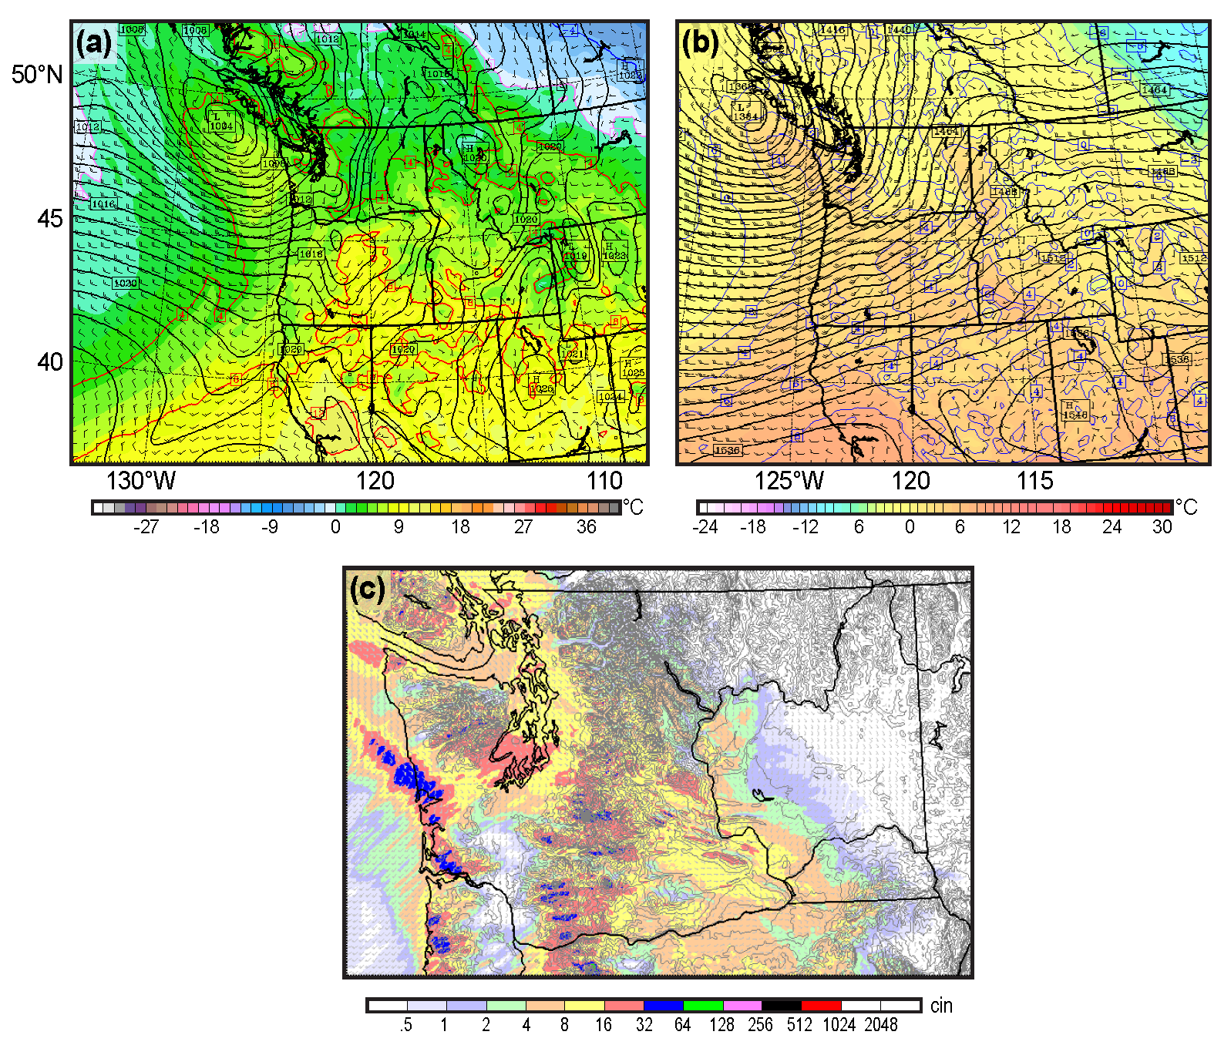
Figure 1: (a) Sea-level pressure (hPa), 925 hPa temperature (°C) and 10-m winds (kt) at 1500 UTC 16 April 2012, (b) 850 hPa geopotential heights (m), temperature, and winds for the same time, and (c) 3-h precipitation for the 3-h period ending the same time. The fields are from a 27-h forecast of the WRF model initialized 1200 UTC April 15, 2012 (12-km grid spacing) for (a) and (b), and 1.3 km resolution for (c).

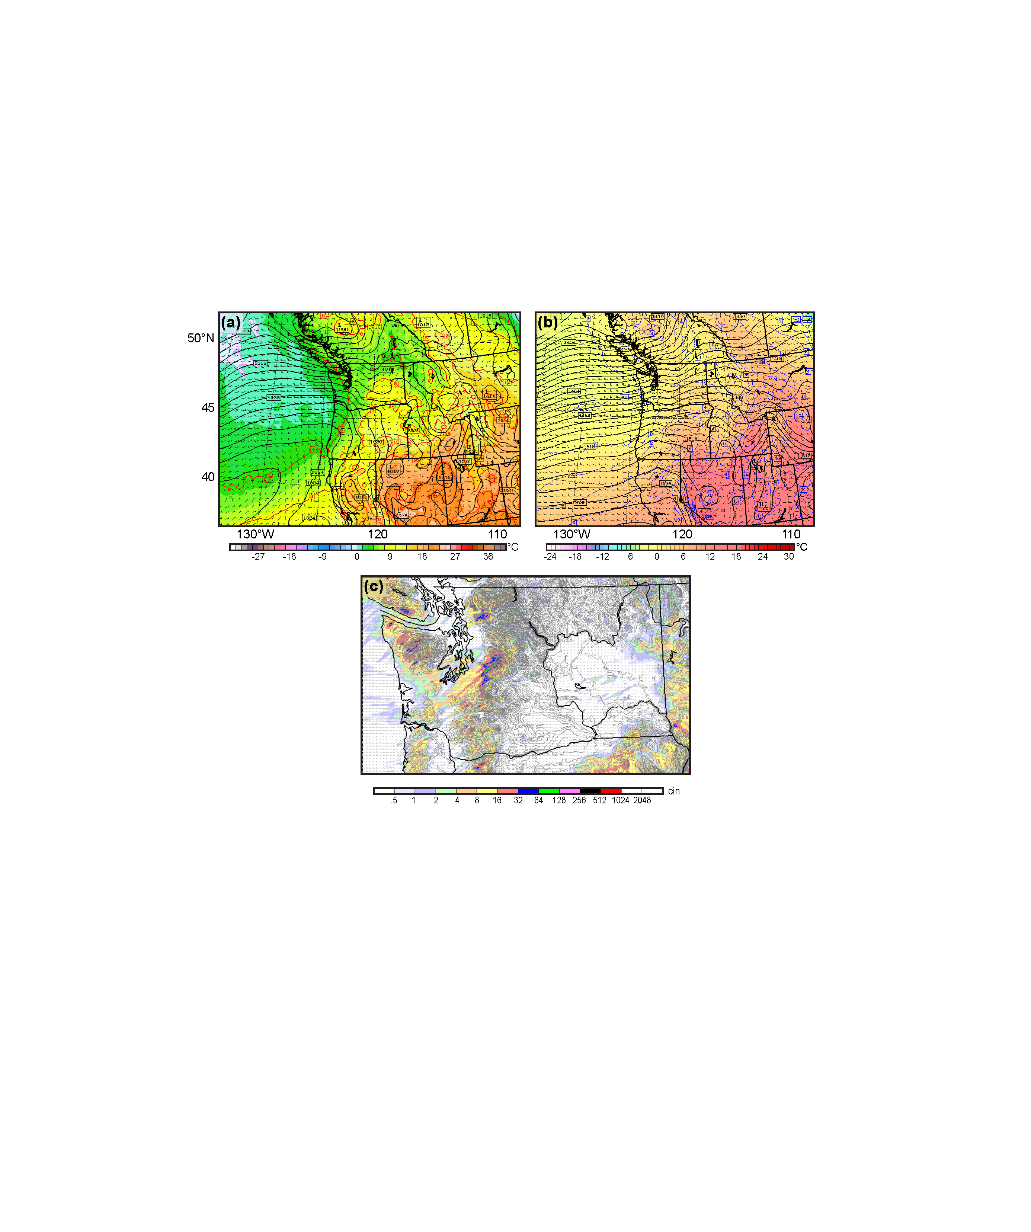
Figure 2: (a) Sea-level pressure (hPa), 925 hPa temperature (°C) and 10-m winds (kt) at 0000 UTC 17 April 2012, (b) 850 hPa geopotential heights (m), temperature, and winds for the same time, (c) 3-h precipitation for the 3-h period ending the same time. The fields shown above are from a 36-h forecast of the WRF model initialized 1200 UTC April 15, 2012

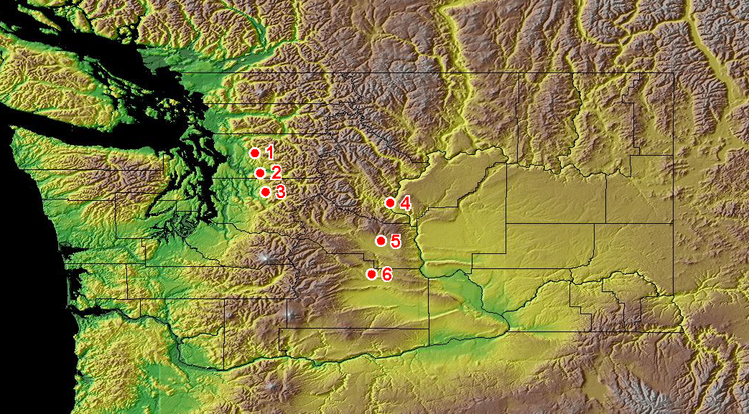
Figure 3: Precipitation gauge sites used in this study and regional terrain. Lines of three stations were created on the western (Spada Lake (1), Gold Bar Elementary School (2), South Fork Tolt Reservoir (3)) and eastern (Yakima (6), Ellensburg (5) and Wenatchee (4)) sides of the Cascade.

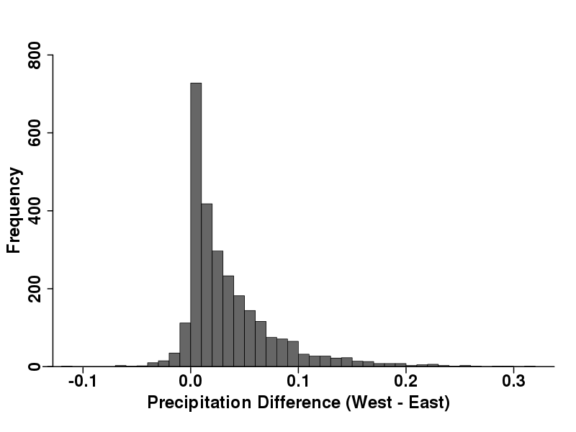
Figure 4. Histogram of the number of hours with various differences in hourly precipitation between the leeward and windward sides of the Cascades from November through February 2011-2013. The differences are between the average hourly precipitation at three sites on both sides of the barrier.
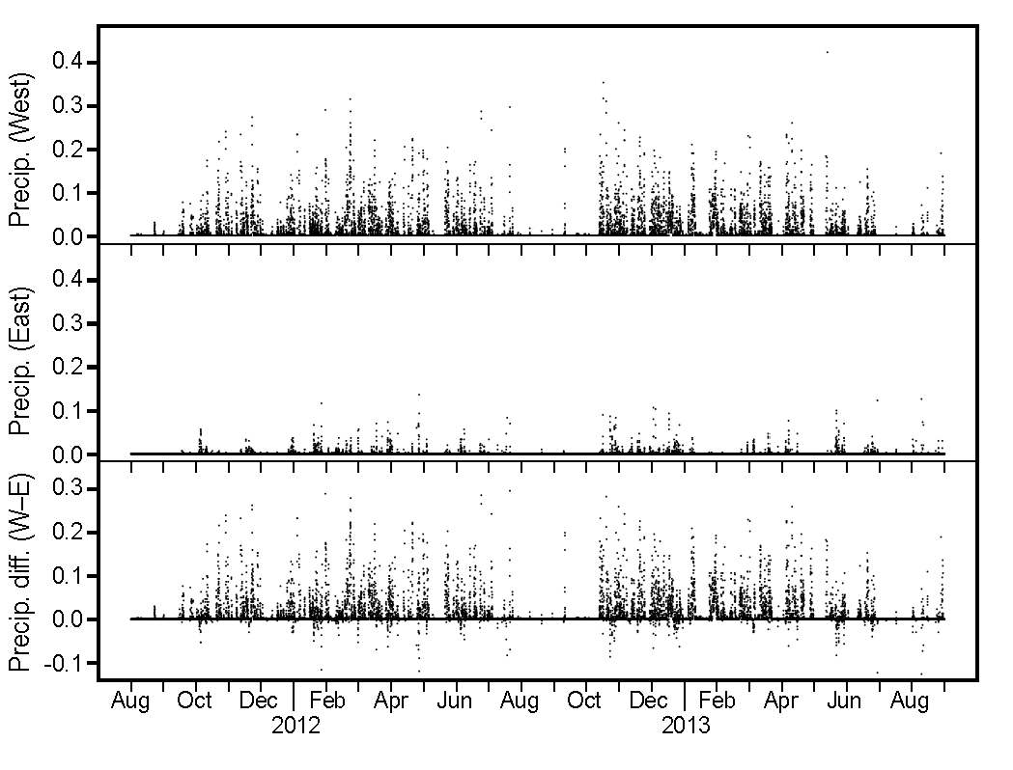
Figure 5: Hourly precipitation along the western and eastern sides of the Cascades, as well as the differences between them.

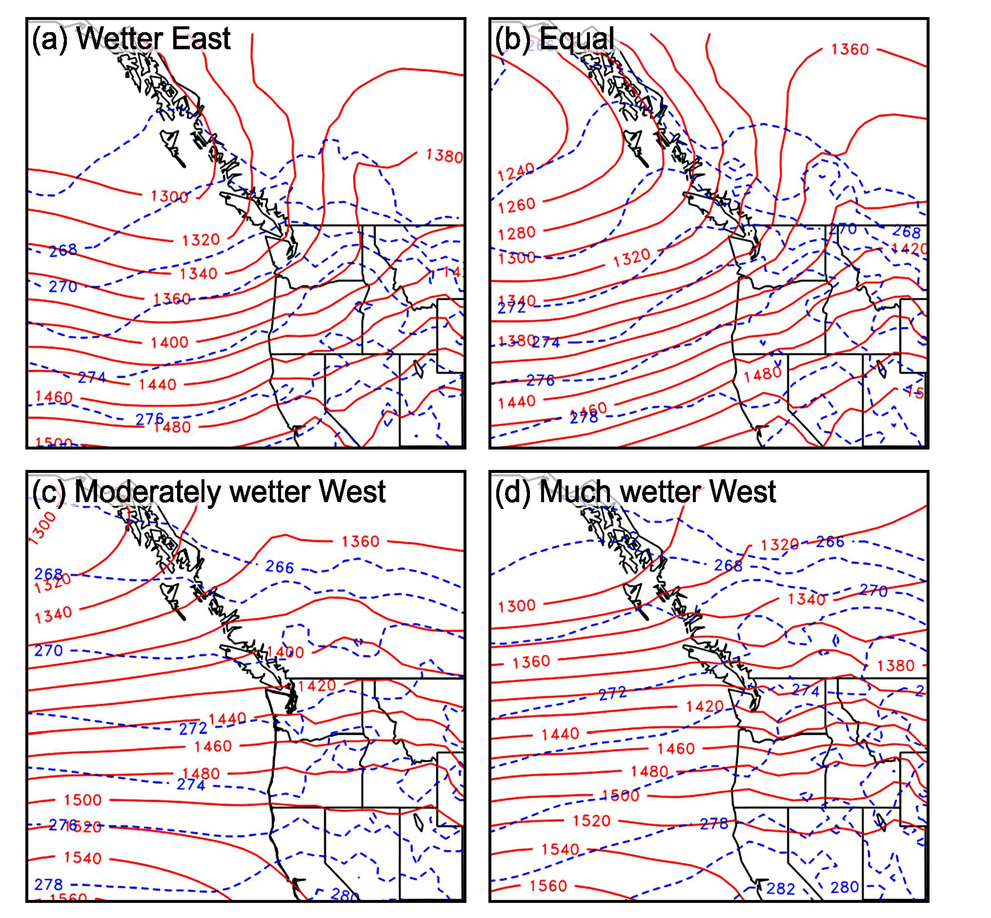
Figure 6: Composites of 850 hPa height (solid red line, m) and temperature (dashed blue line, °K) for four cross-Cascade precipitation regimes.
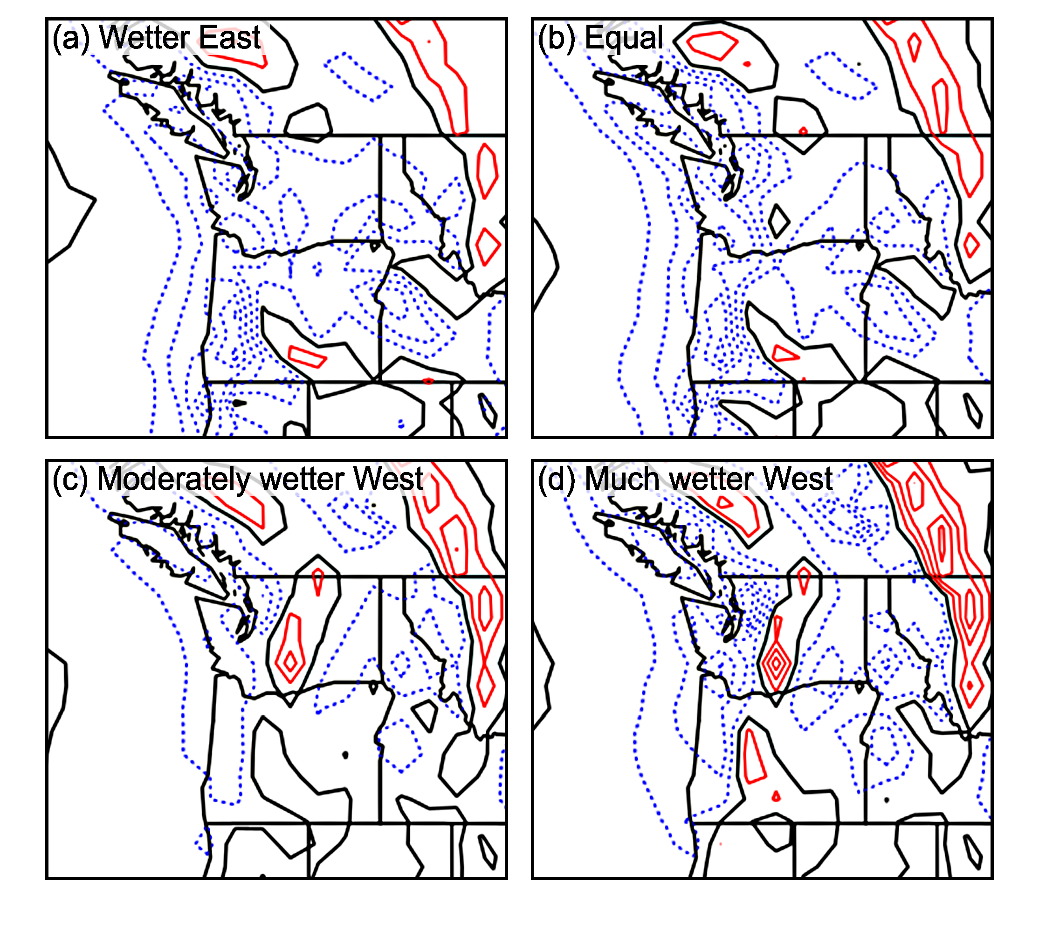
Figure 7: Composite NARR 700 hPa pressure vertical motion (omega, Pa s⁻¹) for four cross-Cascade precipitation regimes. Negative values (upward motion) shown by dashed blue lines. Downward motion by solid red lines. Black contour is zero vertical motion.
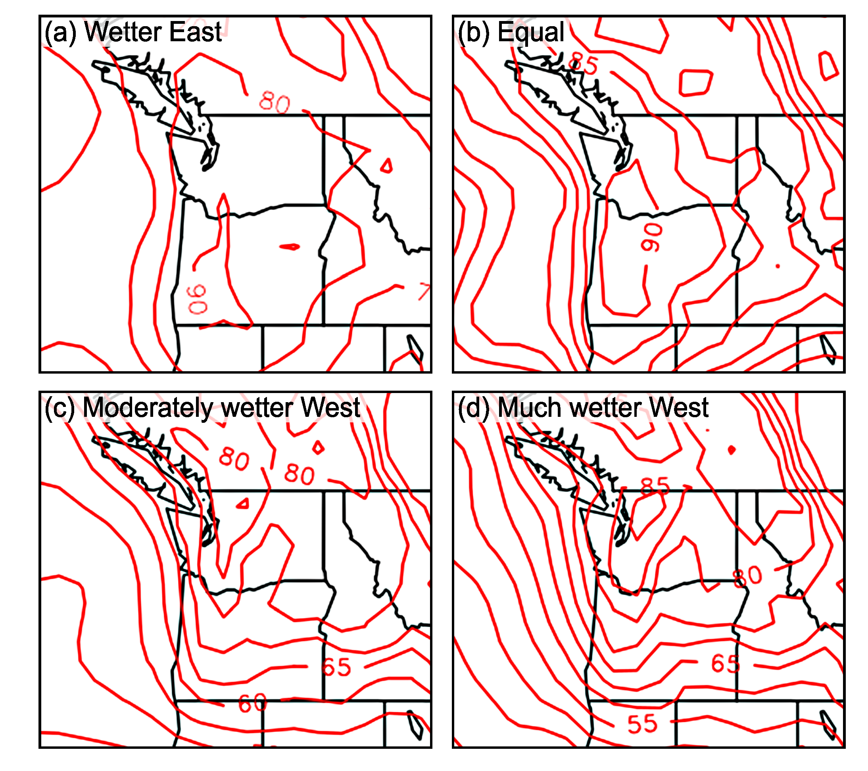
Figure 8: Composite NARR 700-hPa relative humidity (%) for four cross-Cascade precipitation regimes.
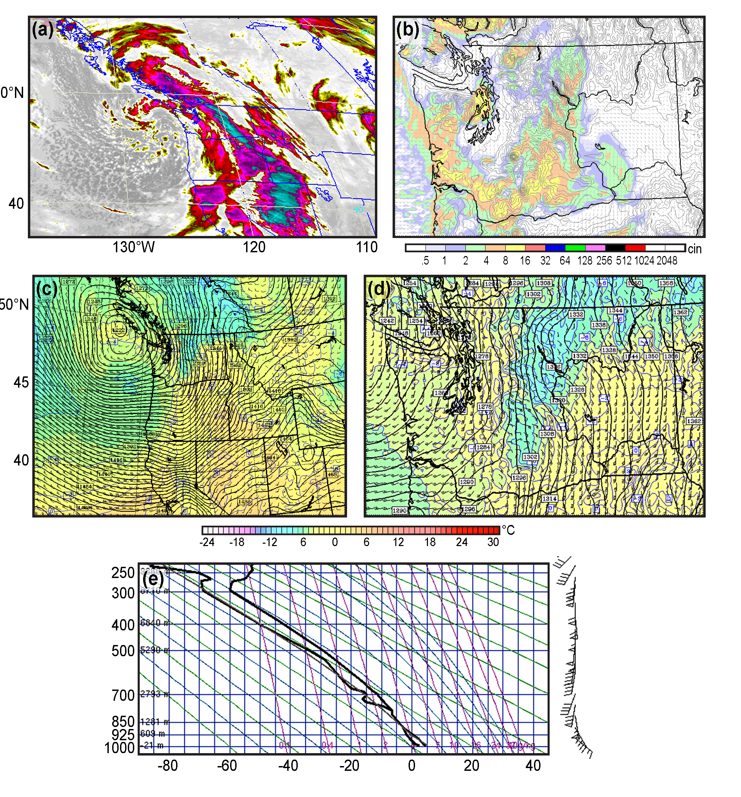
Figure 9: Infrared satellite image (a), WRF 12-km model 3-h precipitation (b) and regional (12-km, c) and local (4-km, d) 850 hPa heights, temperatures and winds at 0600 UTC 29 February 2012. The sounding at Quillayute, WA at 0000 UTC 29 February is also shown (e).

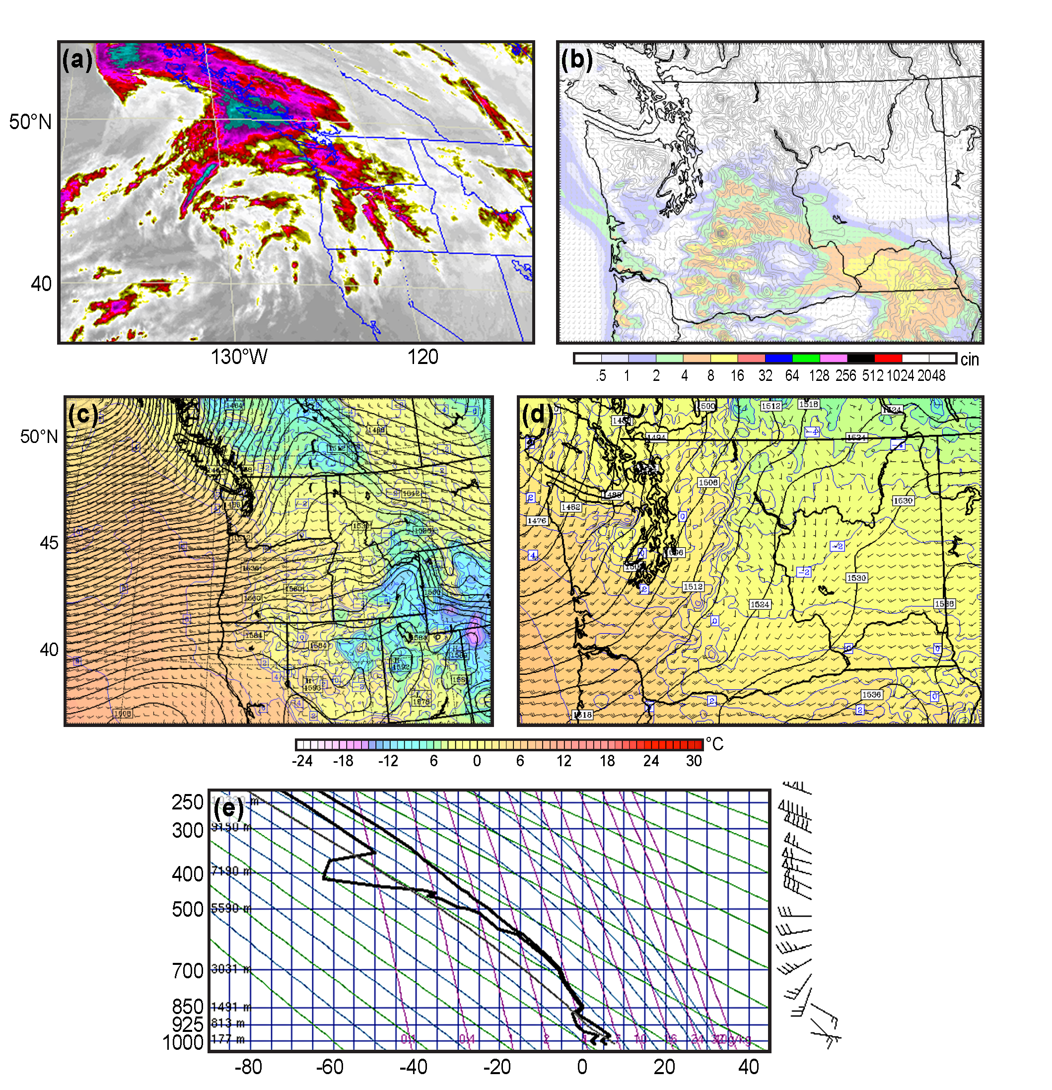
Figure 10. Enhanced infrared (4-km) satellite image (a), WRF model 3-h precipitation (4 km, b) and regional (12-km, c) and local (4-km, d) 850-hPa heights, temperatures and winds at 1500 UTC 28 February 2013. The sounding at Quillayute, WA at 1200 UTC 28 February 2013 is also shown (e).

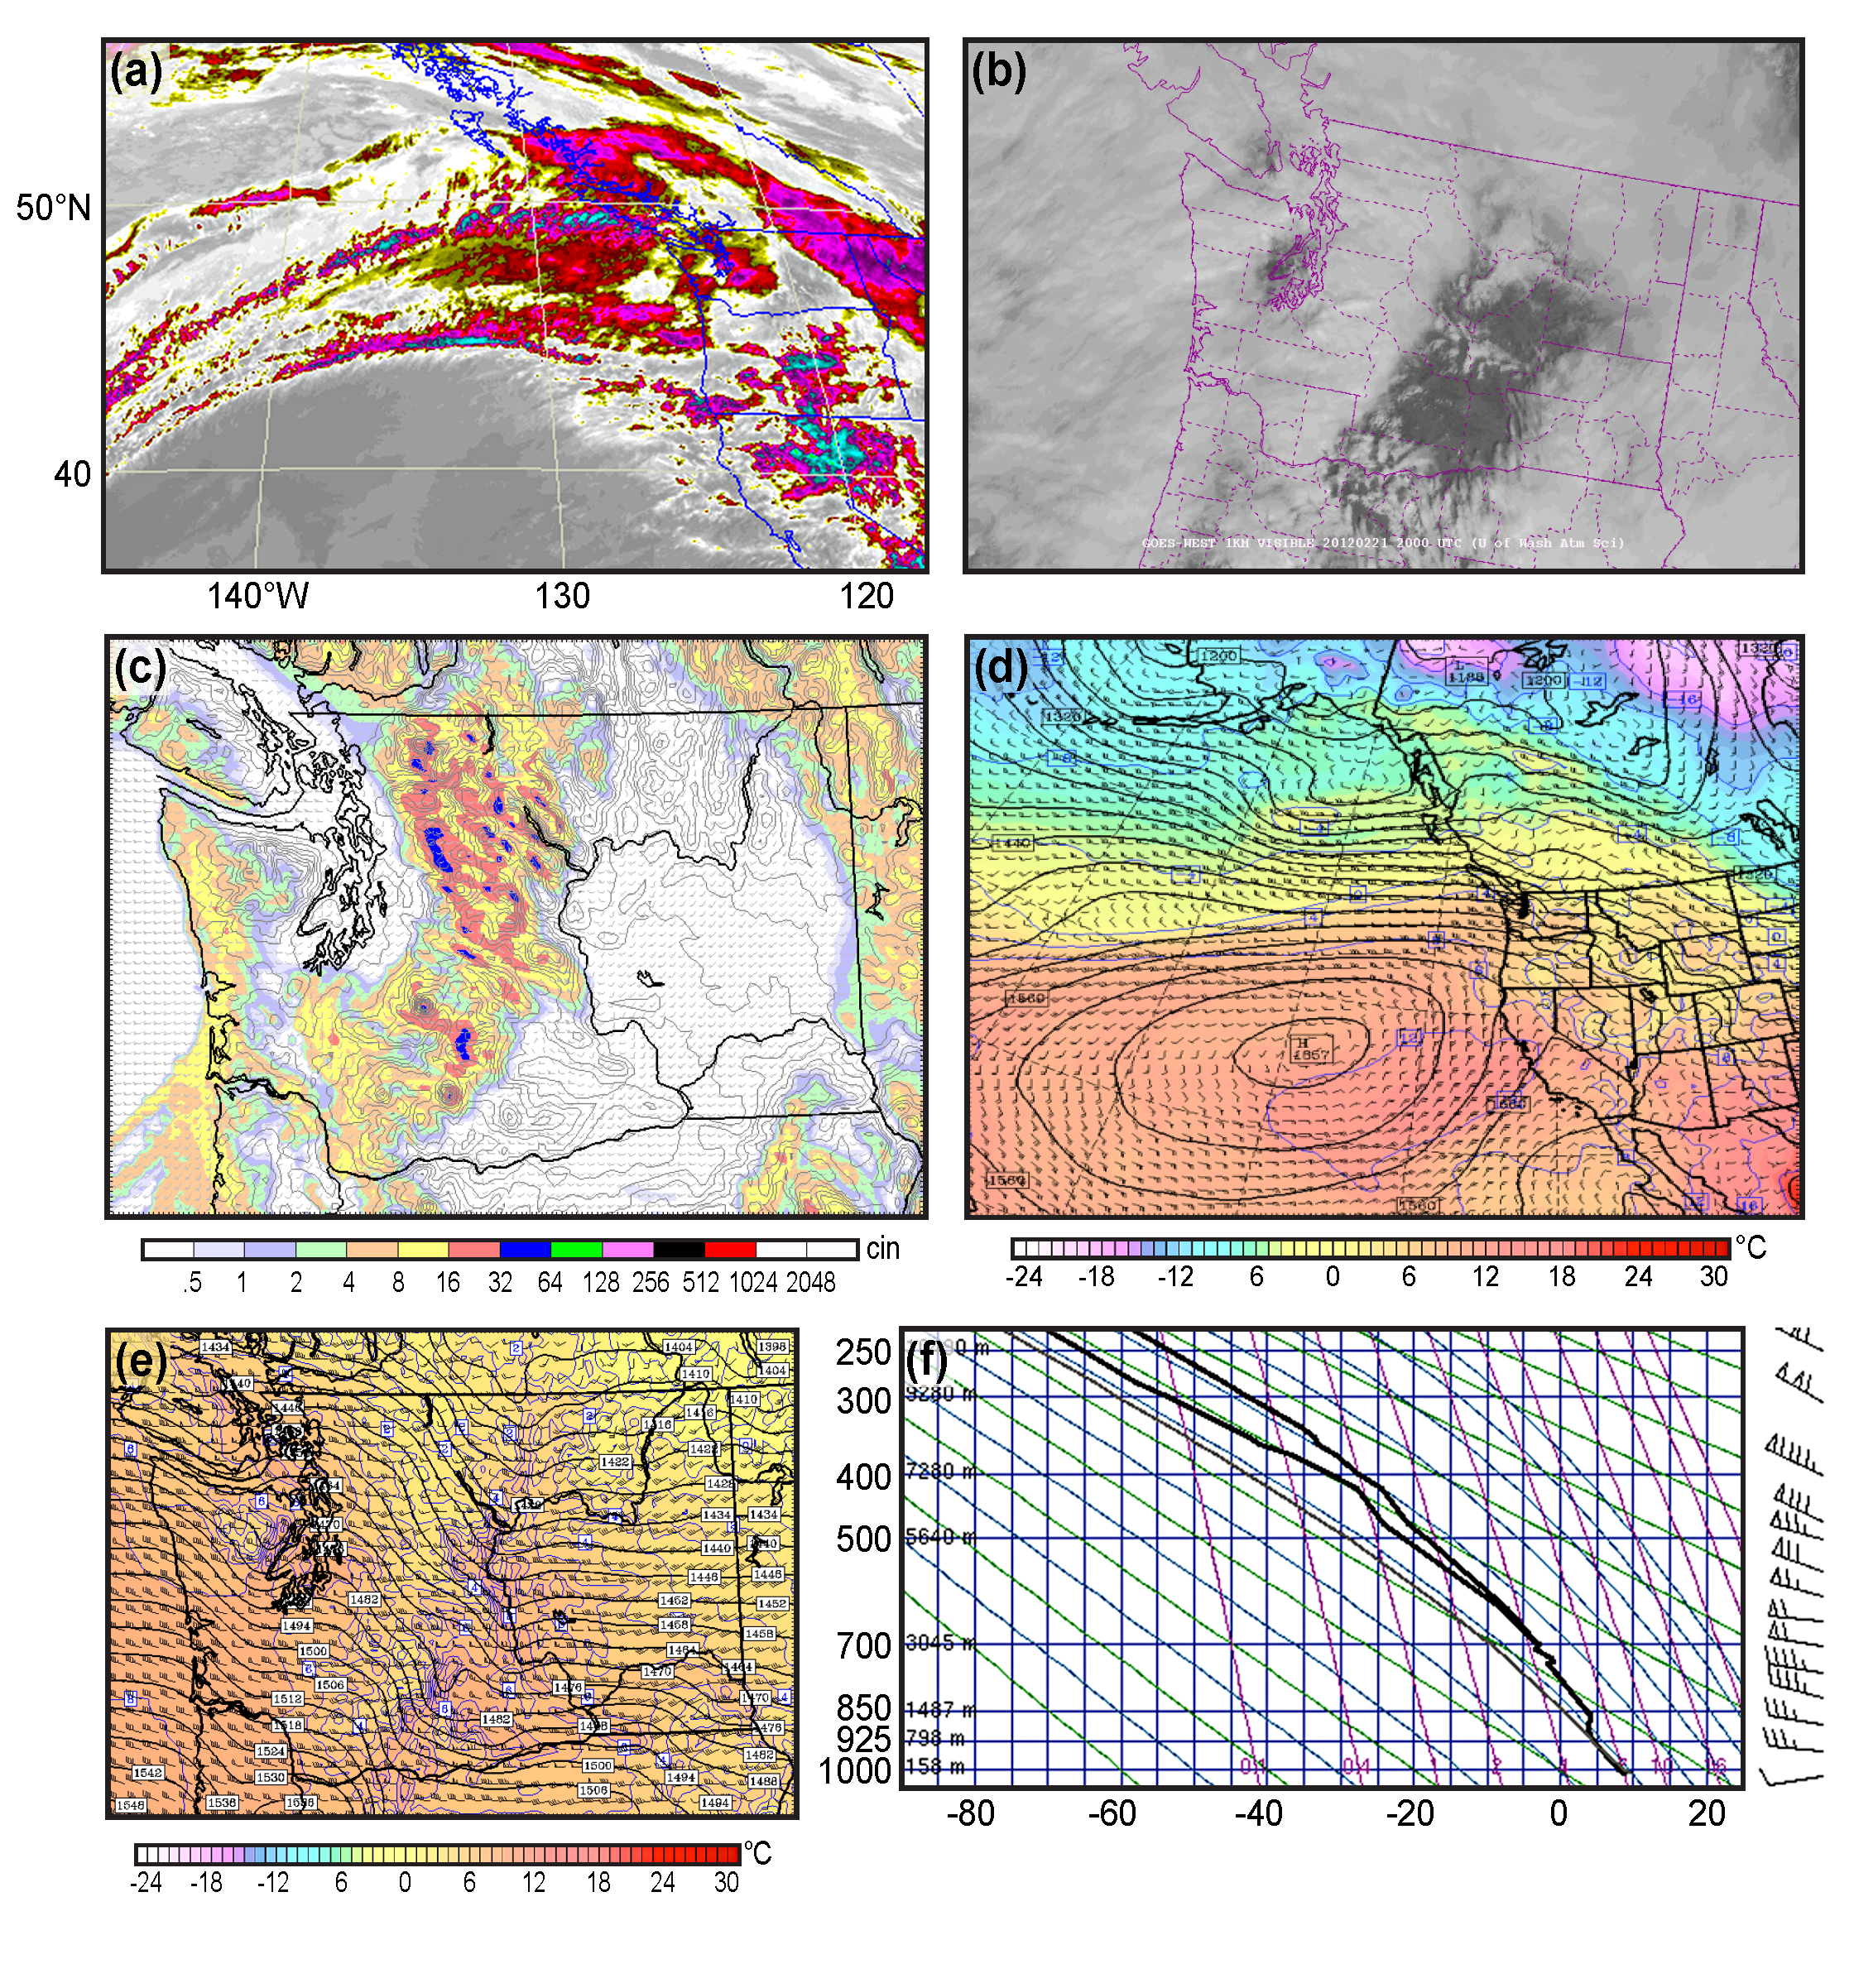
Figure 11: Infrared (4-km, a) and visible (1-km, b) satellite imagery, WRF model 3-h precipitation (4-km, c) and regional (12-km, d) and local (4-km, e) 850-hPa heights, temperatures and winds at 0000 UTC 22 February 2012 (2200 UTC 21 February for visible image), and (f) the sounding at Quillayute, WA at 0000 UTC 22 February 2012.

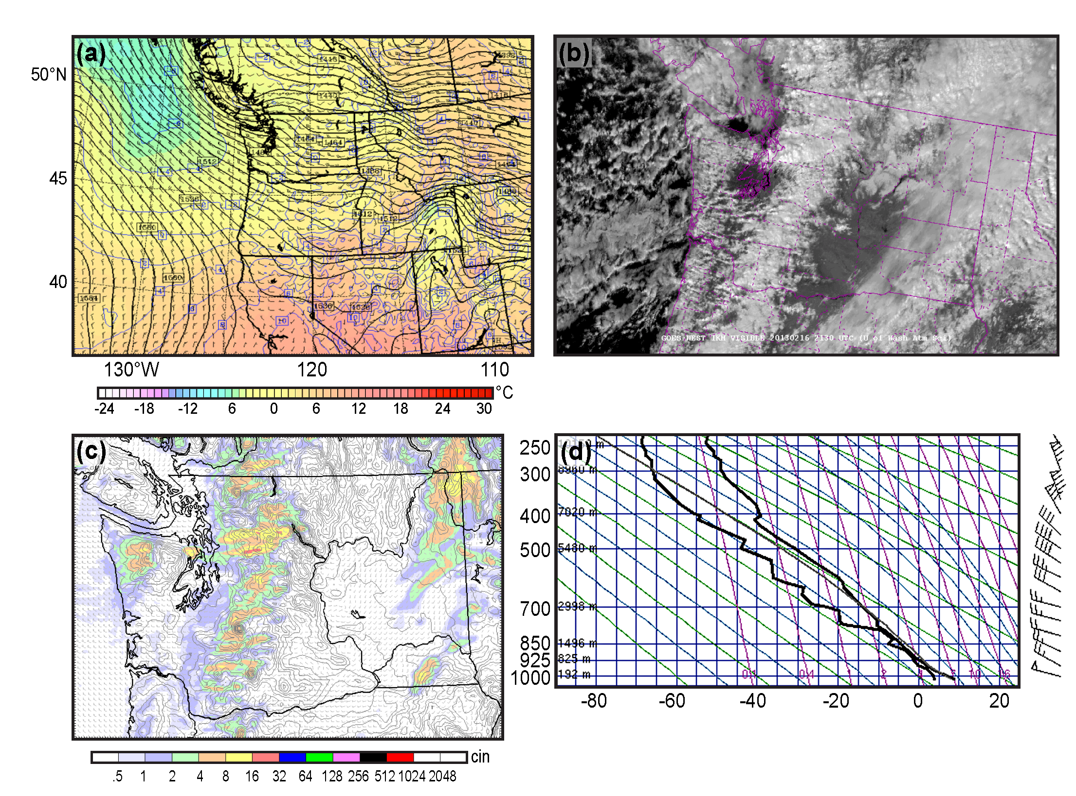
Figure 12: (a) WRF 12-km model 850 hPa heights, temperatures and winds at 2100 UTC 16 February 2013, (b) GOES 1-km visible satellite image at 2130 UTC February 16 2013, (c) WRF precipitation forecast (4-km, run initialized at 1200 UTC 16 February) for the 3-h period ending 2100 UTC February 16, 2013, and (d) the radiosonde sounding at Quillayute, Washington at 0000 UTC 17 February 2013.

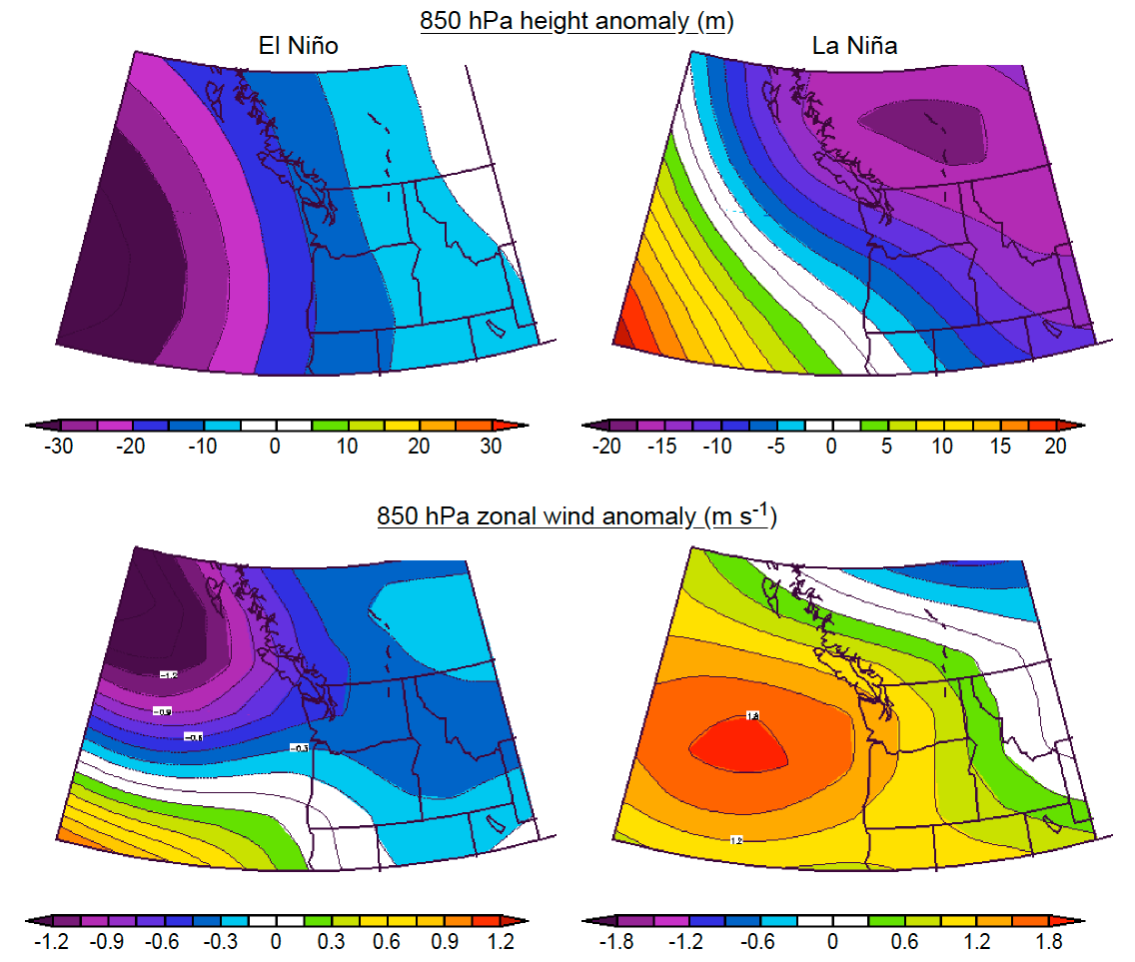
Figure 13: Composites of 850-hPa height and zonal wind anomalies for El Niño and La Niña years for November through February. Based on the NCEP North American Regional Reanalysis (NARR) data set and includes 10 El Niño (1958, 1966, 1973, 1983,1987, 1992, 1995, 1998, 2003, 2010) and 9 La Niña (1956, 1971, 1974, 1976, 1989, 1999, 2000, 2008, 2011) years since 1950.

Corresponding Author Professor Clifford F. Mass Department of Atmospheric Sciences Box 351640 University of Washington Seattle, Washington 98195 cmass@uw.edu (206) 685-0910

